FRAME RELAY
Frame relay is a form of packet switching that provides a streamlined interface compared to X.25 with improved performance.
Accordingly, there is a large installed base of frame relay products. Interest has since shifted to ATM for high-speed data networking, but because of the remaining popularity of frame relay, we provide a survey in this section.
Background
At each hop through the network, the data link control protocol involves the exchange of a data frame and an acknowledgment frame. Furthermore, at each intermediate node, state tables must be maintained for each virtual circuit to deal with the call management and flow control/error control aspects of the X.25 protocol. All of this overhead may be justified when there is a significant probability of error on any of the links in the network. This approach may not be the most appropriate for modern digital communication.
Frame relaying is designed to eliminate much of the overhead involved in X.25. The key differences between frame relaying and a conventional X.25 packet-switching service are as follows;
- Call control signalling is carried on a separate logical connection from user data. Thus, intermediate nodes need not maintain state tables or process messages relating to call control on an individual per-connection basis.
- Multiplexing and switching of logical connections takes place at layer 2 instead of layer 3, eliminating one entire layer of processing.
- There is no hop-by-hop flow control and error control. End-to-end flow control and error control are the responsibility of a higher layer, if they are employed at all.
Thus , with frame relay, a single user data frame is sent from source to destination, and an acknowledgment, generated at a higher layer, is carried back in a frame. There are no hop-by-hop exchanges of data frames and acknowledgments.
Disadvantages
- The ability to do link-by-link flow and error control.
- Hop-by-hop link control is lost.
Advantage
- Streamlined communications process
2.6.1 Frame relay protocol architecture
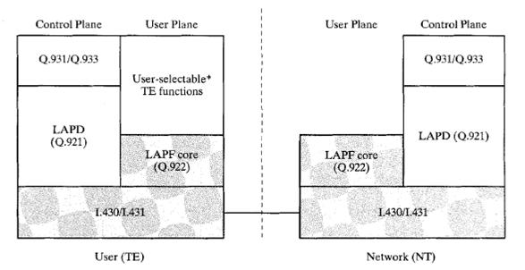
The fig. depicts the protocol architecture to support the frame mode bearer service.
There are two separate planes of operation: a control(C) plane, which is involved in the establishment and termination of logical connections, and a user (U) plane, which is responsible for the transfer of user data between subscribers.
Control plane:
The control plane for frame mode bearer services is similar to that for common channel signaling for circuit-switching services, in that a separate logical channel is used for control information. At the data link layer, LAPD(Q.921) is used to provide a reliable data link control service, with error control and flow control, between user(TE) and network(NT) over the D channel.
User plane:
For the actual transfer of information between end users, the user-plane protocol is LAPF (Link Access Procedure for Frame Mode Bearer Services), which is defined in Q.922. Only the core functions of LAPF are used for frame relay:
- Frame delimiting, alignment, and transparency
- Frame multiplexing/de-multiplexing using the address field
- Inspection of the frame to ensure that it consists of an integral number of octets prior to zero bit insertion or following zero bit extraction
- Inspection of the frame to ensure that it is neither too long nor too short
- Detection of transmission errors
- Congestion control functions
Based on the core functions, a network offers frame relaying as a connection oriented link layer service with the following properties:
- Preservation of the order of frame transfer from one edge of the network to the other
- A small probability of frame loss
User data transfer
Consider the frame format, this is the format defined for the minimum-function LAPF protocol (known as LAPF core protocol). The format is similar to that a LAPD and LAPB with one obvious omission: there is no control field. This has the following implications:
- There is only one frame type, used for carrying user data. There are no control frames.
- It is not possible to use in band signalling; a logical connection can only carry user data.
- It is not possible to perform flow control and error control, because there are no sequence numbers.
The Flag and Frame Check Sequence (FCS) fields function as in HDLC. The information field carries higher-layer data.

